Field Guide for Photo Monitoring

Equipment you will need:

Information you will need:
- Location maps and/or GPS coordinates to locate sites
- Past photos
- History of the site
(Fires, seedings, herbicide treatments, etc.)

- Camera
- GPS (optional)
- 3x3’ frame (optional)
- Photo board or photo board sheet
- Dry-erase markers and pencil
- Step-in post/other way to display photo board in landscape photo
- 100’ measuring tape (optional)
- Site note form (optional)
- Clipboard
Setting up for the photos:
- If your camera or phone has GPS capabilities, turn it on so your device can find its position (see Site Notes).
- (Optional) Place 100’ tape, it assists in replicating the direction and location of landscape photos at certain types of monitoring sites.
- Fill out the photo board. Include the date, site number, and direction of photo.
Taking the photos:
- Reference past photos and study location form to ensure repeat photos are in the same direction and have the same field of view.
- To steady the camera, hold it using both hands with elbows in against the body.
- Take the ground photo first. Set the photo board on the ground next to the frame in the middle right-hand side. Stand over the location. Include the entire photo board in the photograph. Take the photo from a direction that avoids a shadow in the frame (Figure 1. 3x3 photo on back).
- Use a step-in post or have someone hold the photo board so it shows in the right-hand, middle corner of the picture and takes up no more than ¹/₆ of the photo. Place the step-in post on the right side of the photo. Take landscape photo(s) with ¹/₄ skyline and ³/₄ landscape (Figure 2. landscape photo on back).
Site Notes
- Record the GPS coordinates.
- (Optional, but recommended) Document notes on weather (drought patterns, exceptional precipitation), dominant plants (plant seedlings, dead plants), weeds (new weeds, weeds nearby), recent fire, wildlife (grazing, use, rodents, insects), and other relevant info (nearby range improvements, land treatments, management decisions). This is a good activity to start with if you have GPS on your camera so your device can find its position.
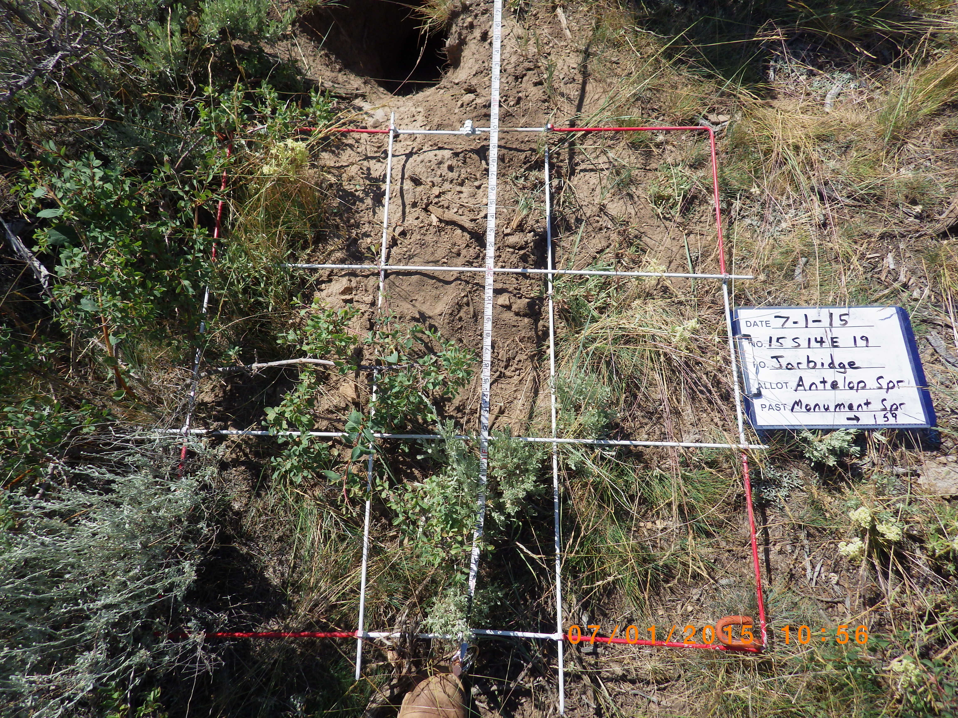
Figure 1. Example photo, frame and tape not required

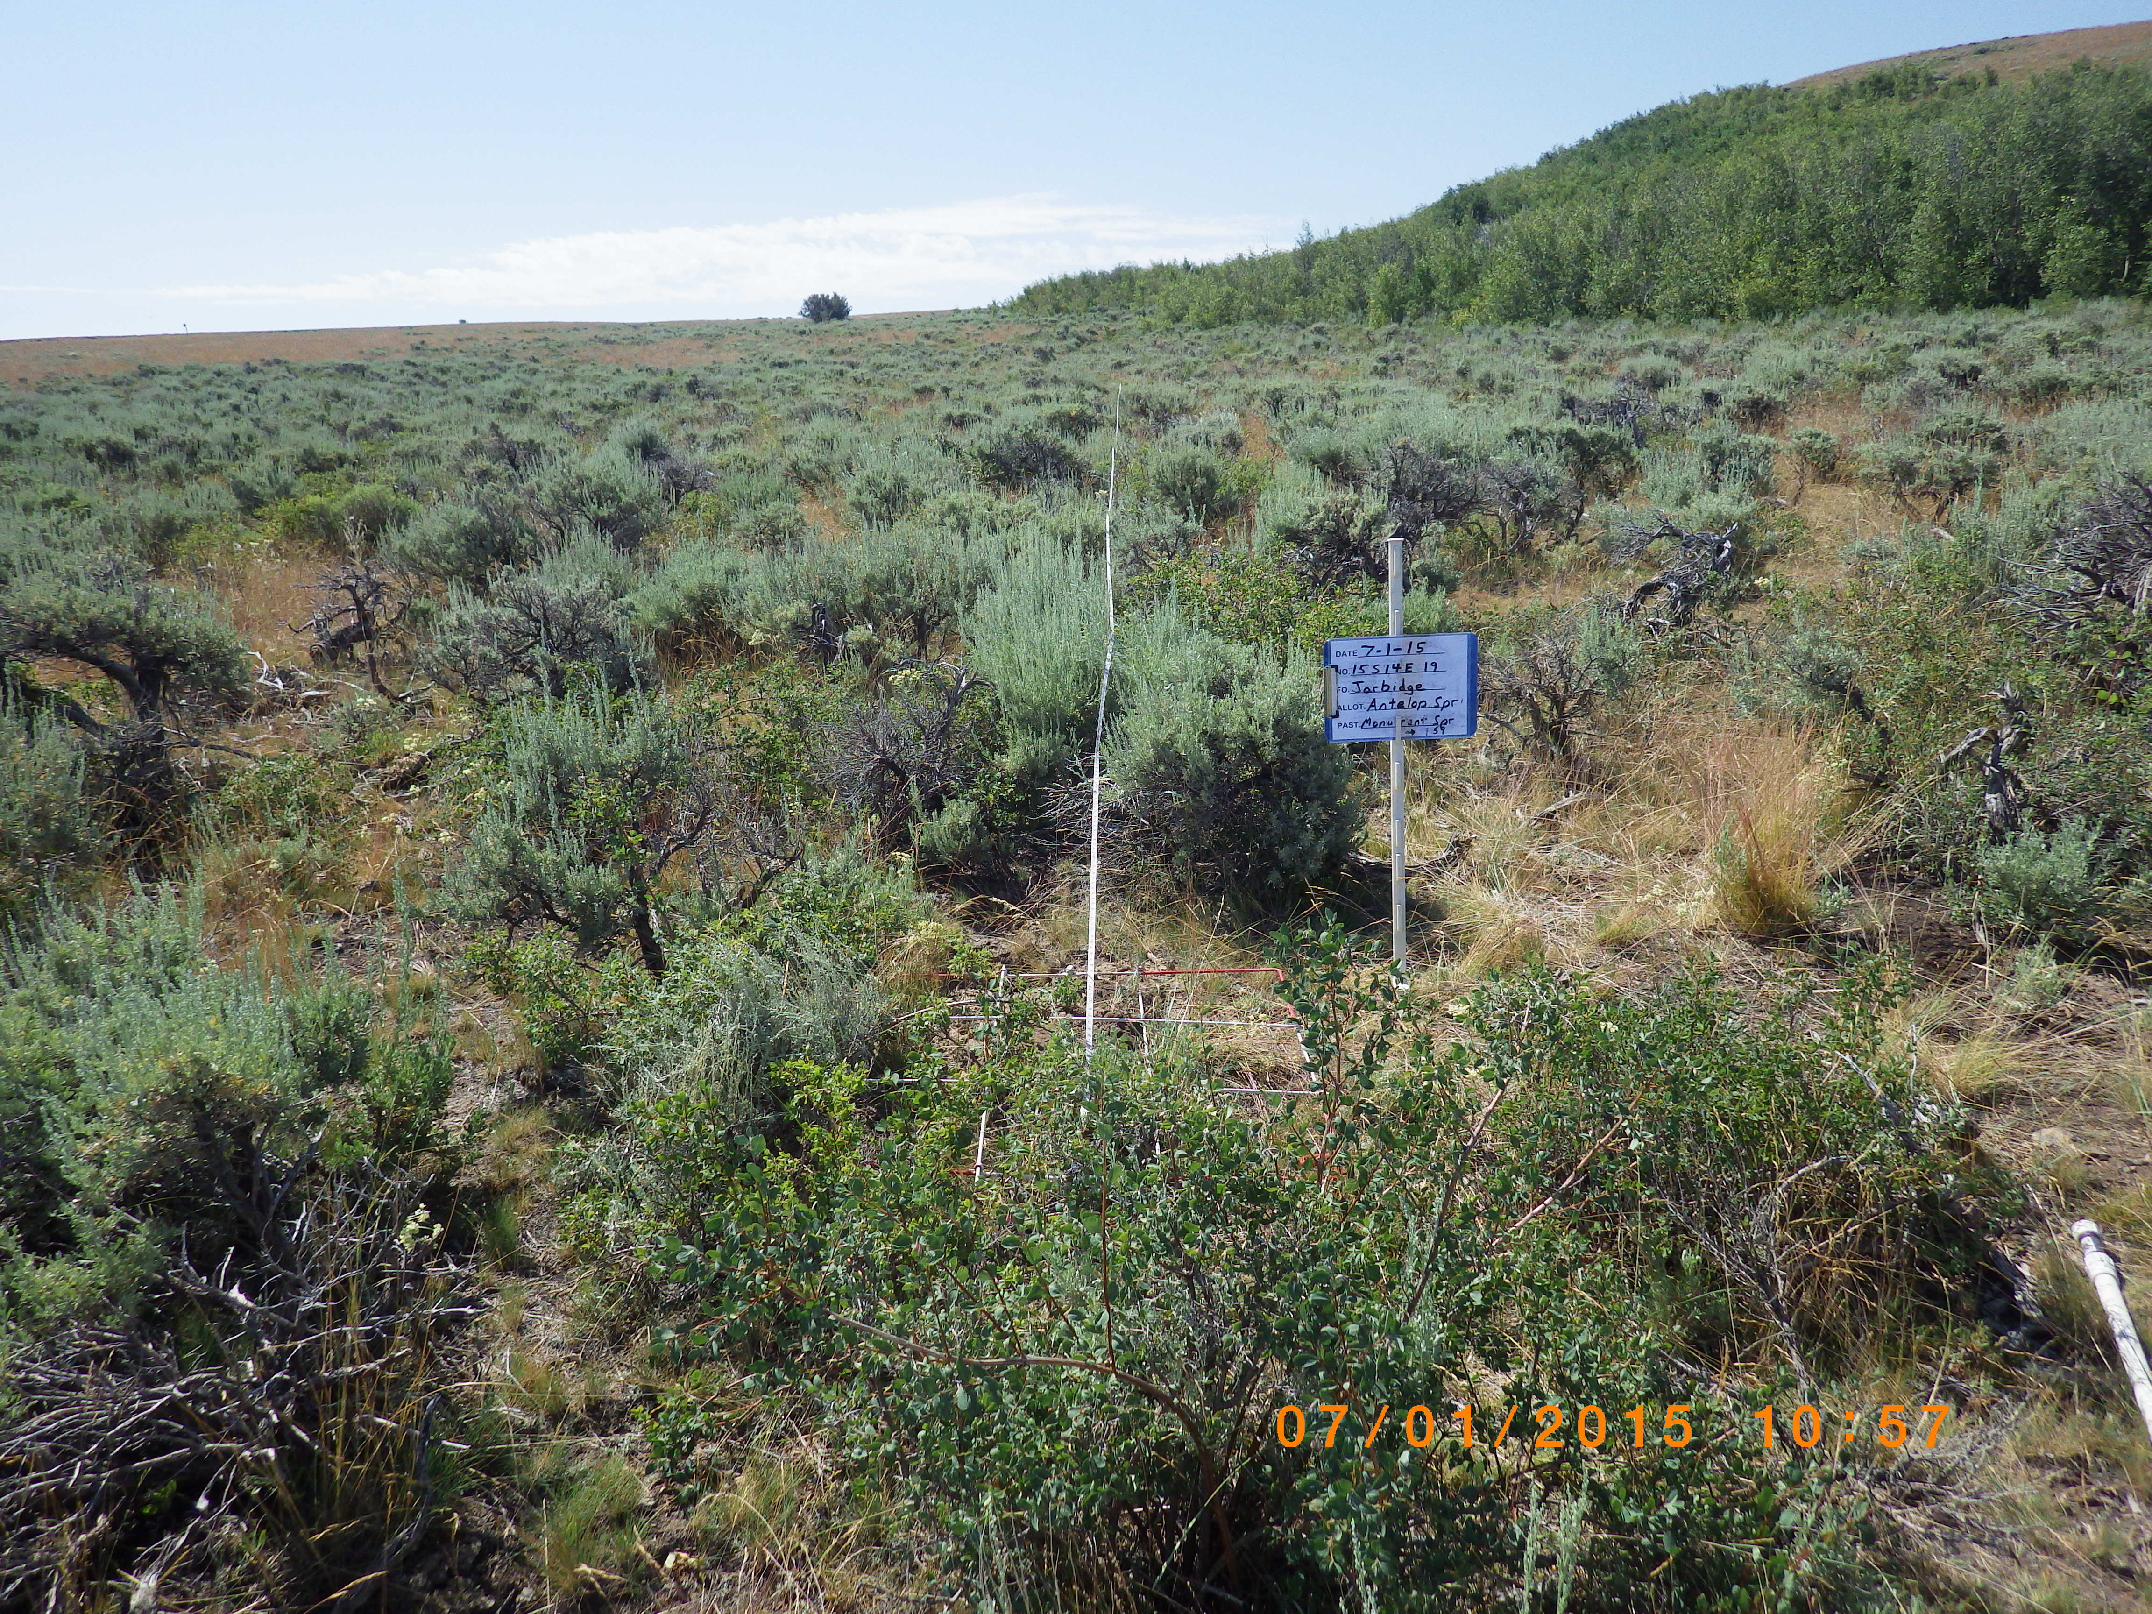
Figure 2. Landscape photo, tape and pole not required

