Sage-Grouse Actions Team
2024-2025, FY25 Funding Cycle
Grant Application Instructions

I. GENERAL INFORMATION

Grant Funds Requested/Total Project Cost—Fill in the amounts, rounded to the nearest dollar, do not include cents. The total project cost is the sum of the match plus the requested grant funding from the proposed project budget (page 6 of the application).

Name of Project—Provide a name, five words or fewer, that can be used for the project on all related correspondence and agreements. Give the project a name that helps to define it, i.e., “Owyhee County Wildfire Rehabilitation,” or “Bear Creek Annual Grass Treatment.” Do not include the word project as they are all projects.

Part I. CONTACT INFORMATION
Information in this section must be complete.

Applicant—Applicant may be a soil and water conservation district, tribe, watershed council, individual, nonprofit organization, university, federal agency, state agency, or local agency. All applicants must be legal entities and supply a Tax Identification Number. Other entities may act on behalf of private landowners, not-for-profit institutions, schools, community colleges, state institutions of higher education, independent not-for-profit institutions of higher education, local agencies, state agencies, or federal agencies if an individual or entity so chooses. Enter all contact information including the contact person. If an entity is acting on behalf of any of the above individuals or groups, they must show consent through signature of the represented individual or group that is being represented.

Fiscal Agent—All applicants must be legal entities and supply a Tax Identification Number. Identify which of these entities will be responsible for tracking project income and expenses and for complying with the grant agreement terms. Enter all contact information. If the fiscal agent is also the applicant, you may write in “Same as Applicant” and leave the contact information blank.

Landowner—
- Private Land: Provide the name of the landowner on whose property the project will be implemented. Enter all contact information. If there is more than one landowner, a cooperative landowner agreement is recommended. However, if a cooperative landowner agreement is not used, attach a separate sheet with contact information for each additional landowner, along with their signatures to attest to the conditions of the application. ALL landowners must either sign the application or a landowner agreement. A copy of the landowner agreement must be sent to the Governor’s Office of Species Conservation (OSC) with the application. If the application is recommended for funding ALL landowners must sign the Grant Agreement.
- Federal Land, State Land or Tribal Land: The project must have approval through the supervisor of that national forest, BLM district, or Idaho Department of Lands District that has jurisdiction for the area in which the project is located. If the project is on tribal land it must have approval through the tribal council that oversees the tribal land on which the project will be implemented. This approval will be through a signature by the appropriate state/federal/tribal individual on page 8 of the application and/or a support letter. If there is a grazing permittee or state lessee they should be made aware of the proposed project and the conditions of the application.

Project Manager for the Grantee—Identify the person who will shepherd the project from start to finish. This person will serve as the main point of contact for the project, and in particular, will be responsible for securing signatures on the grant agreement, seeing that all signatories have copies, and making sure that all required attachments accompany the application and the invoices requesting payment. This person will ensure reports are completed and sent to OSC.

Technical Contact—Identify the person or persons who can answer technical questions about the project (e.g. the Natural Resources Conservation Service (NRCS) or federal agent, Idaho Department of Fish and Game (IDFG), other biologist, etc.) who has worked with the landowner or applicant to develop the project. Enter all contact information.

Part II. PROJECT INFORMATION
- Project Location—
  - State whether your project occurs at a single site or at multiple sites.
- Identify the county or counties the project is located in.
- Identify the Sage-grouse Habitat Management Area(s)(HMA) in which the project will occur; if multiple HMAs, identify the HMA that has greatest percentage of land area covered. The choices are Priority, Important, or General. This can be determined by the Idaho Sage-grouse Habitat map below, your local IDFG biologist, or contact joshua.uriarte@osc.idaho.gov.
- Identify the latitude, longitude coordinate (e.g., -123.789, 45.613) that represents the approximate center of your project area. State which datum you are using to determine this (NAD 83, WGS 84, etc.)
- Identify the land ownership(s) in which the project will occur; public, state, private, and tribal.
- Include a shapefile or location pin of each project element with your application. If the project is on private land, have the landowner’s signature verifying consent for location information.

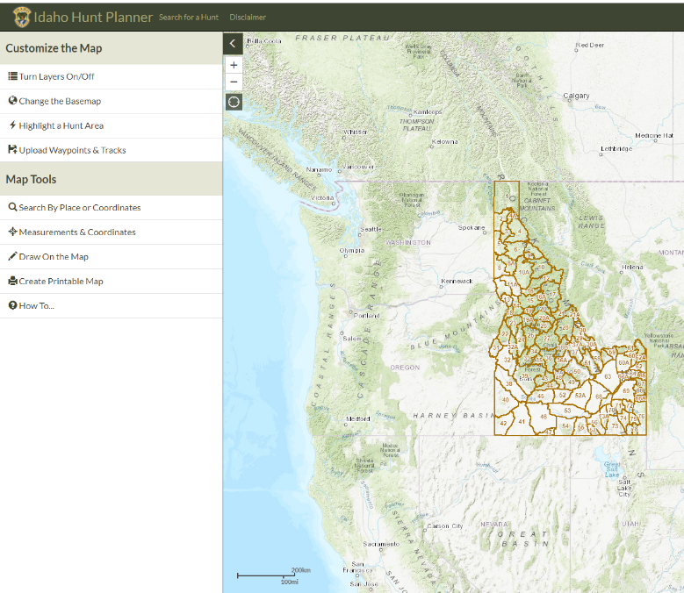
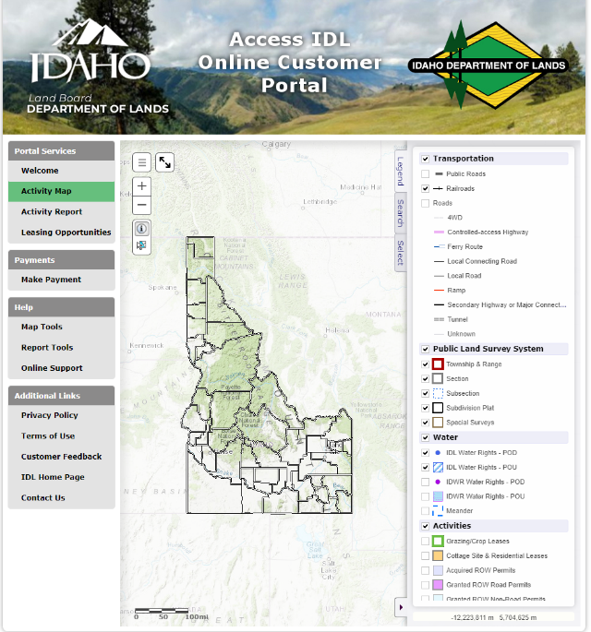
The Idaho Department of Lands record map website or the IDFG Hunt Planner map are online tools for acquiring the county, latitude and longitude coordinates, and land ownership.

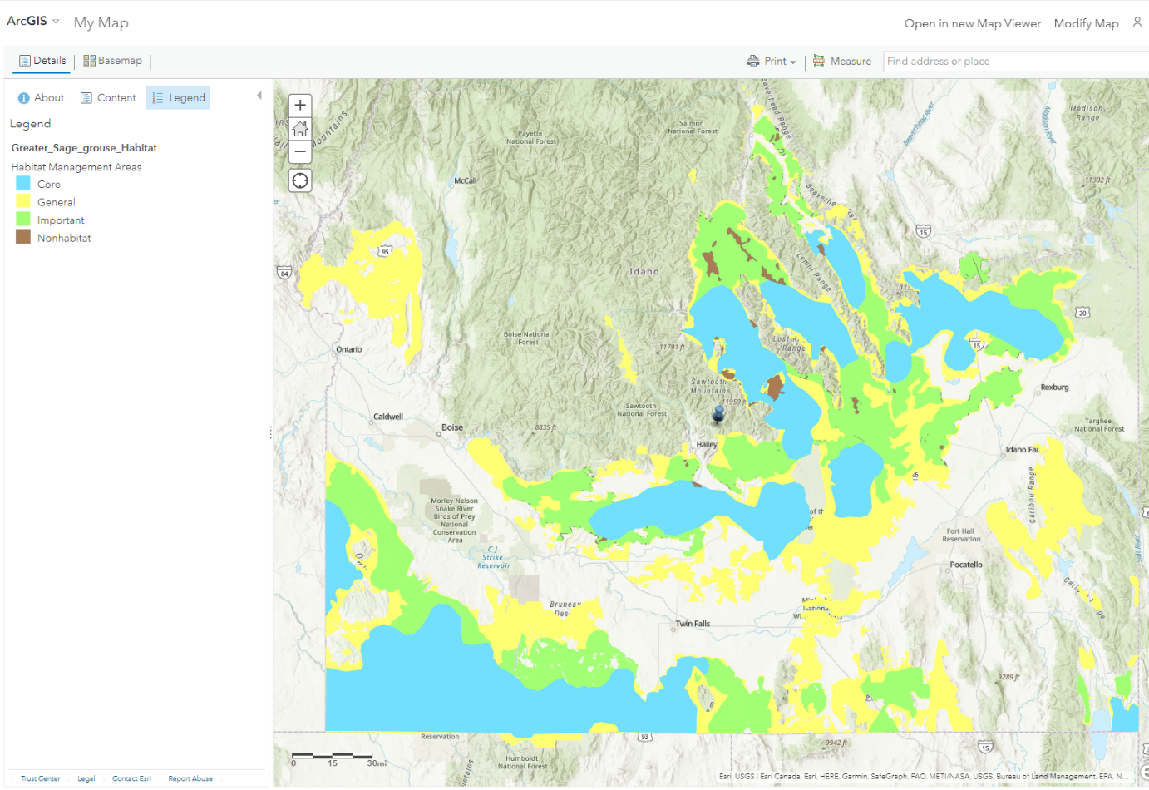
For guidance on Sage-grouse Habitat Management Areas, view maps below, use this link Arc GIS My-Map or contact Joshua Uriarte at Joshua.uriarte@osc.idaho.gov or 1-208-332-1556.

Map Left: Targeted Fine Scale Priority Areas for funding also see Story Map link
*Note: Applications will only be funded if they are within Idaho.

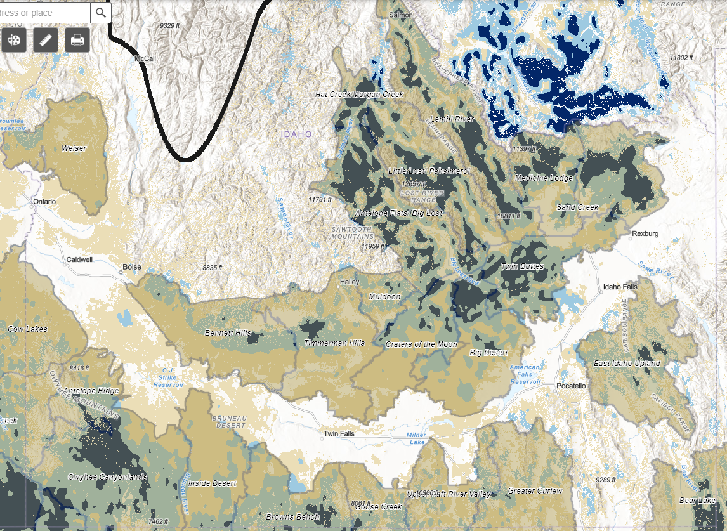
Above: Map showing the USGS Core Sagebrush and Growth Opportunity Areas (Link)
- Narrative—Describe where your project is situated on the landscape and how it fits in with the larger landscape. Describe what regional, state or local priorities or other actions occurring with other partners your project helps complement (i.e. associated with a current or upcoming NRCS application, associated with a larger BLM or USFS restoration project, Cheatgrass Challenge, etc.). Explain the current conditions on the site and describe the baseline before the project (i.e. range condition, plant species present).
- Describe the problem/current threat(s) to sage-grouse you are seeking to address—Describe the threat(s) to sage-grouse that this project is addressing. Primary threats include: wildfire, invasive species, and infrastructure. Secondary threats include but are not limited to conifer encroachment, seeded perennial grasslands (i.e. lacking sagebrush), and improper livestock grazing. If you are looking at addressing limiting factors, they are different for each conservation area and sage-grouse population. Discuss if the threats you are addressing are primary or secondary threats to sage-grouse. Provide detail on any known sage-grouse threats or habitat issues in your project area (e.g., abundant invasive species/annual grasses present, lack of sagebrush, degraded riparian/mesic area condition, degraded upland plant condition, conifer encroachment, livestock impacts, etc.). Talk with local IDFG biologist about what limiting factors may be in your areas and if you have further questions about threats.
- Describe the solution(s) you are proposing that will address the threat(s)—attach a site map, color photos, and (if applicable) project drawings or designs —Describe the proposed solutions or practices (e.g., perennial grass seeding, chemical grass/weed spraying, juniper cutting, fuel break installation, etc.) in sufficient detail to communicate to the project reviewers what you are planning to do and how the practices will address the threats/problems identified.
  - The emphasis should be on how implementation of this project will benefit sage-grouse and sage-steppe habitat. Where applicable, include the number and type of units to be treated by the project and the methods that will be used to accomplish the project. For example, for a fencing project include information on the type of fence, the fencing materials and the length of the fence. For a juniper treatment project include information on what equipment will be used, the number of acres treated, what phase of woodland succession the juniper is currently in, and the current condition of the rangeland. The objectives should be measurable in order to detect change of the pre and post treatment conditions.
  - If this project is a juniper project state how you plan to deal with the slash created from the treatment of juniper (mastication, single tree or pile burning in the winter on frozen ground, hauling the juniper boles away, etc.)
  - If you plan on having a component for burning (broadcast, pile, jackpot, etc.) in your project, state how you will deal with noxious weeds and invasive species in the years after the burning has been implemented.
  - Technical Guidance Source—The project should use the approved technical guidance source listed in this question. If the NRCS Field Office Technical Guide is not used, state the technical guidance source used to design and implement the project. Information on the NRCS approved technical guidance sources for NRCS Idaho is found on at the link below or through your local NRCS office:
The NRCS Idaho Field Office Technical Guide (FOTG).
Section 4 of the FOTG is for NRCS Conservation Practice standards and specifications.

  - Attach a shapefile and maps of the project site with sufficient detail to show the location of the work to be performed. Provide maps on 8½” x 11” pages and include a legend.
For mapping assistance you may contact Joshua Uriarte, OSC Terrestrial Species Program Manager and Policy Advisor, at 208-332-1556, Joshua.uriarte@osc.idaho.gov, your local Soil and Water Conservation District, or local NRCS staff.
Attach color photographs of the site showing current conditions. If doing construction or other engineered work, attach copies of preliminary project drawings or designs.

- What is the anticipated timeline and schedule for the project? Indicate when the project is expected to start, when permits, if needed, will be attained, when monitoring points will be established, when materials will be acquired, when construction will start, and when project will be finished. Project funds awarded must be utilized by June 15, 2025 for state funding sources.

- Have the required permits been obtained for the project? —Indicate whether required permits for the project have been obtained, or if permits are not needed. List the permits that have either been issued (attach copies) or need to be obtained. If permits are needed, copies of the issued permits must be provided to OSC prior to the release of funds. It is the responsibility of the applicant and project manager to acquire the needed permits. Examples of permits include, but are not limited to, waters rights, rights of way, removal/fill, etc.
- Is NEPA needed for this project? Check whether NEPA has been completed or is not required. If the project is planned on federally managed lands or funded in part with federal dollars, having NEPA complete is mandatory for the project to be considered to be ranked for grant funding.
- Maintenance and Post-Implementation Monitoring—Long-term maintenance is the responsibility of the landowner. However, in the short term, the grantee may have an arrangement with the landowner to maintain and monitor the project that should be listed in this section. Refer to the sample below to help you complete the section in the application.
    - What aspects of the project will be maintained? Maintenance is the general upkeep and repair of a project. Examples include, but are not limited to, treating weeds with fuel breaks, treating the juniper limbs or small trees missed after treatment, fixing fence or watering systems to maintain the proper grazing management system, etc.
- What aspects of the project will be monitored Post-Implementation? Post-project monitoring (photo points and visual inspection) is required of all Sage-grouse Actions Team grants and must include photo points and visual inspection. Show in the application what you will be monitoring for (invasive species or noxious species establishing/returning, juniper regrowth after treatment or missed individual juniper, vegetative characteristics for bunch grasses or mesic meadows, seeding establishment/survival, etc.).
- Two years after project completion, the applicant is required to submit a Status Report. This report will indicate the post-implementation success of maintaining and monitoring the project for the two years following completion. (Example: if the project is completed in October 2024, a Status Report on how the project is doing is due two years after, by October 2026.) Note here what, if any, additional aspects of the project will be monitored post implementation. See the links to the Technical Guide and Field Guide to Photo Point Monitoring:
- If you plan to ask for funds that will be used for monitoring you must show: how the monitoring is linked to project objectives, what the type of monitoring you will be conducting and why it is appropriate for this project, what monitoring protocols will be used, and the frequency and duration of the monitoring that you are asking for funding.
Photo Monitoring Technical Guide and Photo Monitoring Field Guide
- Who will be responsible for writing the Year-Two Status Report? — A template for a final report and a year two status report will be provided to you by OSC if your grant is approved for funding.
  - Provide the name and contact information of the individual who will take responsibility for documenting the condition of the project two years after actual project completion date. (This date may be found in the OSC agreement with the applicant.) The individual should generally be either the Project Manager for the Grantee or the Technical Contact. The budget allows this person to be compensated for the report, however it must be built into the budget as a separate line item.
- Technical Assistance: Who will provide technical assistance to the project? Provide the name and contact information for those individuals that are providing the technical assistance to the project. On Question #4 –Solution: state what their responsibilities are; designer, planner, etc. If the project is being designed include the experience that demonstrates your designer has the experience and qualifications needed to design the project. Also, include how the design takes into consideration extreme events (i.e. 100-year floods) as well as alternatives that were looked at.
- Project Partners—Identify all anticipated funding sources—groups, volunteers, or agencies participating in the project, what they will do and if they are providing in-kind match or dollars to the project. List any agencies, volunteers, or groups who will assist with the design or implementation of the project and describe briefly what they will do and the estimated value. For example, indicate that the landowner will purchase sagebrush seedlings and Idaho Fish and Game will donate the use of their planting equipment; an NRCS employee will design the project, or student volunteers will plant the seedlings in areas where the equipment cannot reach.
- Project Budget Estimate—The budget template is available in Word format. Fill in the information requested in ALL columns. Refer to the sample budget on page 6. List the items, amounts, and sources of funding for expenses associated with the project. Include the dollar value of donated services and supplies in this table under the “Cost Share/In-Kind” column. List all items requesting Sage-grouse Actions Team funds under the “Sage-grouse Actions Team Funds” column. Fill in the amounts, rounded to the nearest dollar, do not include cents. Include a justification on where prices were gathered. Acquiring estimates from contractors to help the review committee understand if the budgeted dollars are sufficient to complete the project and address the threats is recommended. Other ways to estimate price may come from local NRCS or Soil and Water Conservation District offices.

  - Cost Share/In-Kind/Cash (Match)—The Actions Team gives higher ranking scores for greater amounts of match. Match funding sources may come from other non-Actions Team grants, cash donations, donated labor or services, and donated supplies or materials. Other Actions Team or OSC grants may not be used to satisfy the match requirement. Match should be shown in a letter from the partner providing the match, with signatures and dollar amount expected as match. This letter is recommended to be submitted with the project application. IMPORTANT: Match claimed for one grant may not be claimed for any other grant.

  - Match Definitions
- Cash Match: Actual cash paid by the applicant for a service or product. This includes any cash funds that were donated to the applicant to offset the costs of a specific item.
- In-Kind Match: Services or goods that are donated to the project by the applicant or a third party.

Eligible Match
- Cash or in-kind resources that are for work/dollars spent during the same timeframe as the proposed project, the matching work or cash cannot be completed/spent before the approved grant agreement is signed.
- Cash or in-kind resources that are implementing a similar practice/action as the proposed project and done in concert with the proposed project.
- Cash and in-kind resources that are integral to the successful completion of the project and align with the proposed ecological objectives.
- Cash or in-kind contributions are defined as resources that further the grant objectives and are necessary to achieve the proposed outcomes.

Ineligible Match
- Mitigation funds
• Cash and in-kind resources that are not necessary to the successful completion of the project and do not complement the proposed ecological objectives.

- Description of Budget Line-Item Expense Categories—Complete only the line items that apply to your project. Indicate the Number of Units and the Unit Cost wherever appropriate. Be sure to include information requested in the Description column.
- Contracted Services—Includes all acceptable costs (i.e. labor, materials/supplies, and travel) associated with hiring consultants, construction firms, or other outside firms. Landowners performing work for the grant are to be paid from this category. Contract costs should be broken out and should match the scope of work described in the application.
- Materials and Supplies— List all the supplies and materials purchased by, or invoiced to the applicant for the project, such as fencing, pipes, seed, plants, boulders, logs, shovels etc., that are typically “used up” in the course of the project. Group similar supplies (e.g., boulders and logs, trees and shrubs) on the same line. Indicate the Number of Units and the Unit Cost wherever appropriate. The Action Team have discretion in deciding appropriate costs for supplies and materials. However, supplies and materials must be directly related to the on-the-ground work; Actions Team Funds will not provide funding for film, education and outreach materials, first aid kits, or interpretive signage (funding up to $200 for signs listing funding partners is allowed).
- Other—Refers to items that do not fit in the other budget categories (i.e. Land Use signature costs). These items may be incurred prior to start date of grant.
- Grant Administration— Add up the Actions Team Funds column and enter the amount here. The cost for grant administration may not exceed 5% of the grant award amount for direct project costs, showing in the Modified Total Direct Total Cost (MDTC) line, EXCEPT, if the MDTC is $2,000 or less, the grant administration may be funded up to $200.
- Post-Grant—The Actions Team requires a post-implementation status report two years following the actual project completion date. (This date will be reflected on the agreement between OSC and the applicant). Year-Two Status Report may not be budgeted for under the “Actions Team Funds,” the cost should be put toward the match funds.
- Project Totals—Add up the “Sage-grouse Actions Team Funds” column and enter the amount. Add up the “Cost Share/In-Kind” column and enter the amount. The total of the “Cost Share/In-Kind” column is recommended to be at least 25% of the total “Sage-grouse Actions Team Funds” column.
- Signatures—The applicant, landowner, and fiscal agent must sign the application. If more than one landowner is involved, add signature lines to the application and have each landowner involved sign and date. On a separate page spell out what each landowner plans to contribute to the project. NOTE: ALL landowners must sign the subsequent Grant Agreement if the grant is funded.
- Project Checklist—Include attachments as appropriate/required. Check the corresponding box once you have attached the item to the application.
- Sample Budget (Word)—The following is an example of a completed budget in Word format. If you would like to use the Excel version, please contact Joshua Uriarte at OSC.
Fill in the amounts, rounded to the nearest dollar, please do not include cents.
Expense Category | No. of Units |  | Unit Cost | Cost Share In-Kind/ Cash (Match) | Actions Team  Funds | Description--what will be purchased or done and who will provide the item/perform the work
CONTRACTED SERVICES Labor, supplies, and materials to be provided by non-staff for project implementation
Brush Hog Operation | 8 hrs |  | $25 | $200 | $0 | Landowner’s time for operating equipment
Tractor Operation | 10 hrs |  | $25 | $250 | $0 | Landowner’s time for operating equipment
Tree Planters | 30 hrs |  | $10 | $300 | $0 | 5 FFA students planting trees
Fencing Labor | 150 hrs |  | $15 | $ | $2,250 | 3 contracted workers to install fence
Auger | 8 hrs |  | $40 | $ | $320 | Used to plant trees
Tractor | 10 hrs |  | $40 | $400 | $ | Used to plant trees & clear planting locations
SUBTOTAL(1) |  |  |  | $1,390 | $2,570
MATERIALS AND SUPPLIES Refers to items that are purchased by or invoiced to the applicant, and are “used up” in the course of the projects. Costs to the Actions Team must be directly related to the implementation of this grant.
Trees and shrubs | 600 |  | $0.50 | $0 | $300 | 24” seedlings / 2-year shrubs = bare root
Fencing Materials | 1000 ft |  | $1.20/ft | $0 | $1,200 | 4-strand barbed wire smooth bottom wire
SUBTOTAL(2) |  |  |  | $0 | $1,500
OTHER Land use signature costs, project permit costs, small equipment repair, commercial equipment rental.
 |  |  | $0 | $0 | $0
SUBTOTAL(3) |  |  |  | $0 | $0
MODIFIED TOTAL DIRECT COST (MTDC)  (Add Subtotals 1-3) |  |  |  | 1,390 | $4,070
GRANT ADMIN. Not to exceed 5% of Modified Total Direct Costs (MTDC). Compute by multiplying MTDC by 0.05 or less.
Grant Administration by Applicant |  | 5% of MDTC |  | $0 | $203
PROJECT TOTALS |  |  |  | $1,390 | $4,273

