Office of Species Conservation

Brad Little P.O. Box 83720
Governor Boise, Idaho 83720-0195

Mike edmondson 304 North Eighth Street, Suite 149

Administrator Boise, Idaho 83702-5833

February 2024

Request for Sage-grouse Habitat Restoration Projects

The Idaho Governor’s Office of Species Conservation (OSC) and Sage-Grouse Actions Team (Actions Team) are accepting proposals for sage-grouse habitat restoration projects. There will be $600,000 available for funding projects contingent on approval by the legislature for state Fiscal Year 2025 (FY25) to implement actions outlined in the Governor’s Sage-grouse Management Plan (2021 Idaho Plan) https://gov.idaho.gov/wp-content/uploads/2022/03/Attachment1_2021IdahoPlan-FINAL.pdf . The Actions Team works with partners to secure and leverage additional funding to support sage-grouse conservation in Idaho.

OSC and the other state agencies charged with implementing the 2021 Idaho Plan (Idaho Department of Lands and Idaho Department of Fish and Game) partnered with federal agencies (FWS, BLM, USFS, and Natural Resources Conservation Service), as well as the Idaho Soil and Water Conservation Commission, Idaho State Department of Agriculture, and The Nature Conservancy to create the Actions Team. The Actions Team meets regularly to identify, prioritize, and fund projects that target the primary threats (invasive plant species and wildfire) and limiting factors to sage-grouse.

The grant application form, application instructions, ranking information and Request for Proposals (RFP) documents can be found on the OSC website (https://species.idaho.gov/sage-grouse-actions-team/).

Projects that will rank higher in FY25 are located in the following Focus Areas based on the 2020 GRSG Adaptive Management Team Recommendation Report (https://species.idaho.gov/wp-content/uploads/2022/02/GRSG-Management-Recommendations-Report-2020.pdf) and within one of the Core Sagebrush Areas or Growth Opportunity Areas from the USGS’s Sagebrush Conservation Design (https://pubs.usgs.gov/publication/ofr20221081). Note: Projects outside of these prioritization areas will be accepted but will not receive the additional ranking score.
(For Focus Area locations see the Application Instructions or click this link Story Map)
(For an interactive map to look at the Sagebrush Conservation Design Core Sagebrush and Growth Opportunity Areas go to: https://gs-portal-fws.hub.arcgis.com/apps/fws::sagebrush-geospatial-layer-visualizations/explore)

Funding will be prioritized for projects that address threats to sage-grouse, including:
- Invasive annual grass treatment
- Juniper removal
- Wet meadow/riparian restoration
- Wildfire prevention (i.e. Strategic Fuel Breaks, Engine Fill Stations)
- Wildfire rehabilitation

Project ranking criteria will also emphasize:
- Collaborative project proposals that span multiple land ownerships and benefit large landscapes
- Projects on state and private lands
- Projects that provide matching funds
- “Shovel ready” projects that can be completed by June 2025
Applications for this application period, FY25, must be received by Friday, May 3, 2024.
Funds will be available to successful applicants on July 1, 2024.
Submit applications electronically, in person, or by mail to one of the addresses below.
Award notifications will be sent after projects are ranked and approved by the Actions Team mid-May.

Mailing and hand delivery:  Idaho Office of Species Conservation  Attn: Joshua Uriarte  304 N. 8th Street, Ste. 149  Boise, ID 83702 | Electronically:  species@osc.idaho.gov

Your role in sage-grouse conservation across Idaho’s rangelands is crucial to protect and restore key habitat areas and support the economic vitality of rural communities in Idaho.

For additional information or questions please contact Joshua Uriarte (OSC) at 208-332-1556, or joshua.uriarte@osc.idaho.gov.

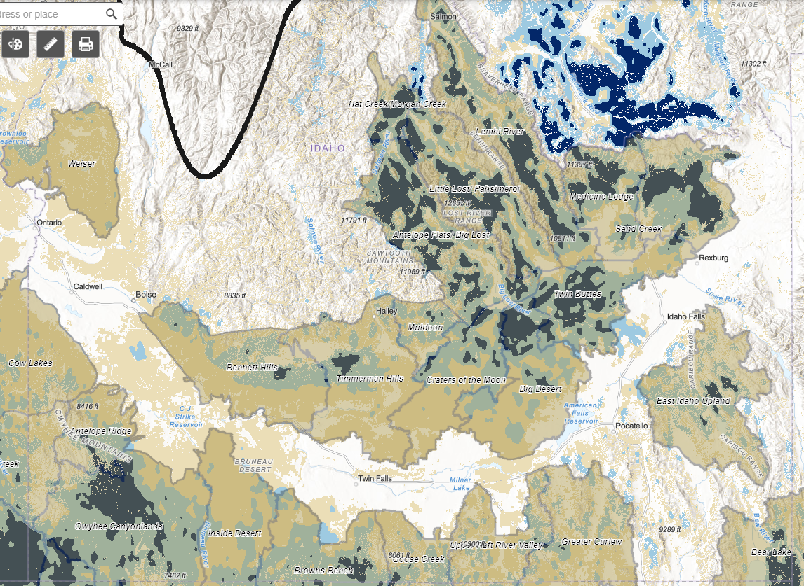
Fine Scale Areas with Core Areas (dark blue) and Growth Areas (light blue)

